https://cepr.org/voxeu/columns/easy-money-easy-spending-new-take-resource-curse

Easy money, easy spending: A new take on the resource curse
- Rabah Arezki

- Hieu Thi Hoang Nguyen

- Frederick van der Ploeg
- /
7 Sep 2025
When wealth or income suddenly increases (‘easy money’), this may be directed towards unproductive ‘easy spending’. This column explores the relationship between conspicuous consumption and revenue windfalls using country-specific variations in commodity export prices, and finds that the responses are bigger for luxury than for non-luxury imports. Countries that have higher inequality, weaker control of corruption, or less democracy have significantly higher luxury import responses following a commodity export windfall. These results suggest a novel (conspicuous consumption) channel of the resource curse in the context of weak mechanisms for resource allocation.

Authors



Rabah Arezki



Hieu Thi Hoang Nguyen



Frederick van der Ploeg

Share
- Twitter
- Facebook
- LinkedIn
- Bluesky
When wealth or income suddenly increases, colloquially referred to as ‘easy money’, this may be directed towards unproductive use, referred to as ‘easy spending’. At the individual level, the psychology of easy money and its resulting effect on spending behaviour stem from a combination of our brain’s reward system and social influences – including as a result of the ‘keeping up with the Joneses’ effect. A large body of literature has investigated the behaviour of lottery winners, including how these winners end up spending their prize money.
There is, however, little systematic evidence as to whether an ‘easy money, easy spending’ conundrum is present at the macroeconomic level, which might be especially salient for commodity-exporting economies that are subject to large price swings, presenting them with large revenue windfalls. In a recent paper (Arezki et al. 2025), we provide new evidence of the cross-country relationship between conspicuous consumption – that is, the purchase of luxury goods or services for the purpose of displaying wealth – and (commodity) windfalls.

Conspicuous consumption, the ‘nouveau riches’, and the resource curse
The study of conspicuous consumption dates back at least to Veblen (1899) and Bourdieu (1979). Interestingly, Veblen uses the phrase of conspicuous consumption to describe the behaviour of the social class of ‘nouveau riches’ who emerged during the Second Industrial Revolution. Similarly, the commodity price supercycle that started in the early 2000s appears to have disproportionately benefited the nouveau riches in commodity-exporting economies, who have engaged in conspicuous consumption. Anecdotal evidence from industry reports on global luxury trade places these commodity exporters at the centre. The class of nouveau riches from commodity-exporting countries, whether from the Gulf countries, Africa, or Central Asia, is visible in luxury shopping destinations such as the Champs-Elysees in Paris and New Bond Street in London.
The dependence of exports on natural resources leads to macroeconomic challenges (Arezki et al. 2017). One is the excessive indebtedness of economies experiencing the bust of a resource boom. From a normative standpoint, economies subject to windfalls should invest domestically, especially if they are capital scarce, as pointed out by Collier et al. (2010) and van der Ploeg and Venables (2011). From that perspective, conspicuous consumption is wasteful but may result from a skewed allocation of revenue windfalls among the population.
Another challenge is the Dutch disease wherein a natural resource discovery or price increase of the exported resource is accompanied by an overvalued real exchange rate, which in turn shrinks the non-resource export sector. This leads to loss in ‘learning by doing’ and less cumulative causation in the traded sector, so that temporary shocks lead to permanent output losses (van Wijnbergen 1984). Most of the attention has so far been focused on the export channel of the resource curse. Yet, the import base is as large as the export base, if not larger, in many commodity-exporting countries. There is no a priori reason to consider that the ‘import channel’ of the resource curse is less powerful than the export channel.

Empirical approach
To examine the cross-country relationship between conspicuous consumption and commodity terms of trade shocks, we estimate the responses of demand for imports of luxury goods resulting from plausibly exogenous variations in commodity export prices.
To do so, data on luxury imports are used, where we define as luxury products those whose individual valuation is above a 40th percentile threshold for each relevant import categories of goods at the 6-digit HS codes using United Nations-COMTRADE data. Luxury imports constitute an important share of global trade, accounting for approximately 15% of global merchandise imports in 2023 in our dataset.
To estimate the relationship between commodity terms-of-trade shocks and luxury imports, we use the IMF Commodity Price Index (CPI). A casual look at the data suggests that the relationship is strong. For example, in Saudi Arabia an increase of 12.39 points in the Commodity Export Price Index in 20214, according to our calculations, corresponded to a $1.828 billion (14.9%) increase in luxury imports in the following year.

Luxury versus non-luxury imports following commodity windfalls
To systematically test whether the response of luxury goods imports to commodity windfalls is bigger than for non-luxury imports, we estimate the impulse responses of the share of luxury imports over total imports. There is a statistically significant and persistent positive effect of commodity price shocks on the share of luxury imports. Our calculations show that, on average, a unit increase in commodity export prices leads to approximately a 0.12% increase in the share of luxury goods in imports in the following year. An increase of one standard deviation in the CPI in our sample (3.24 points) thus corresponds to a 0.39% increase in the luxury share (see Figure 1).
Figure 1 Responses of luxury shares in imports to a terms-of-trade shock
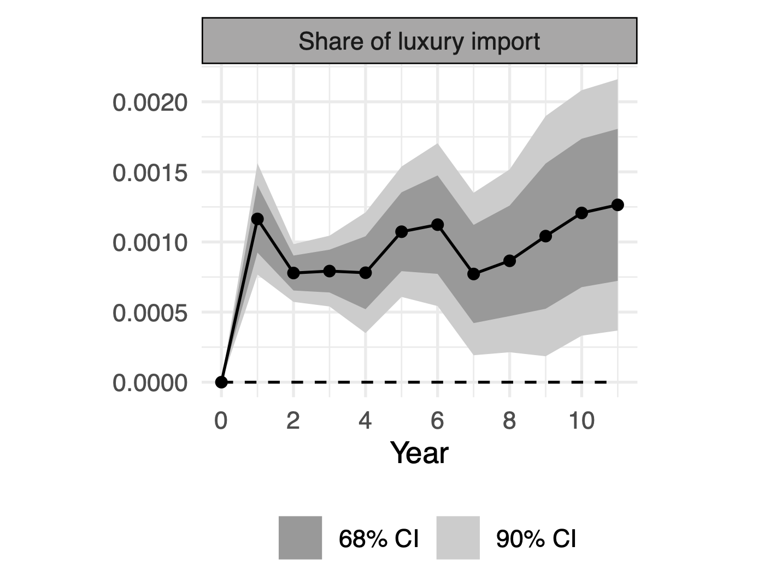
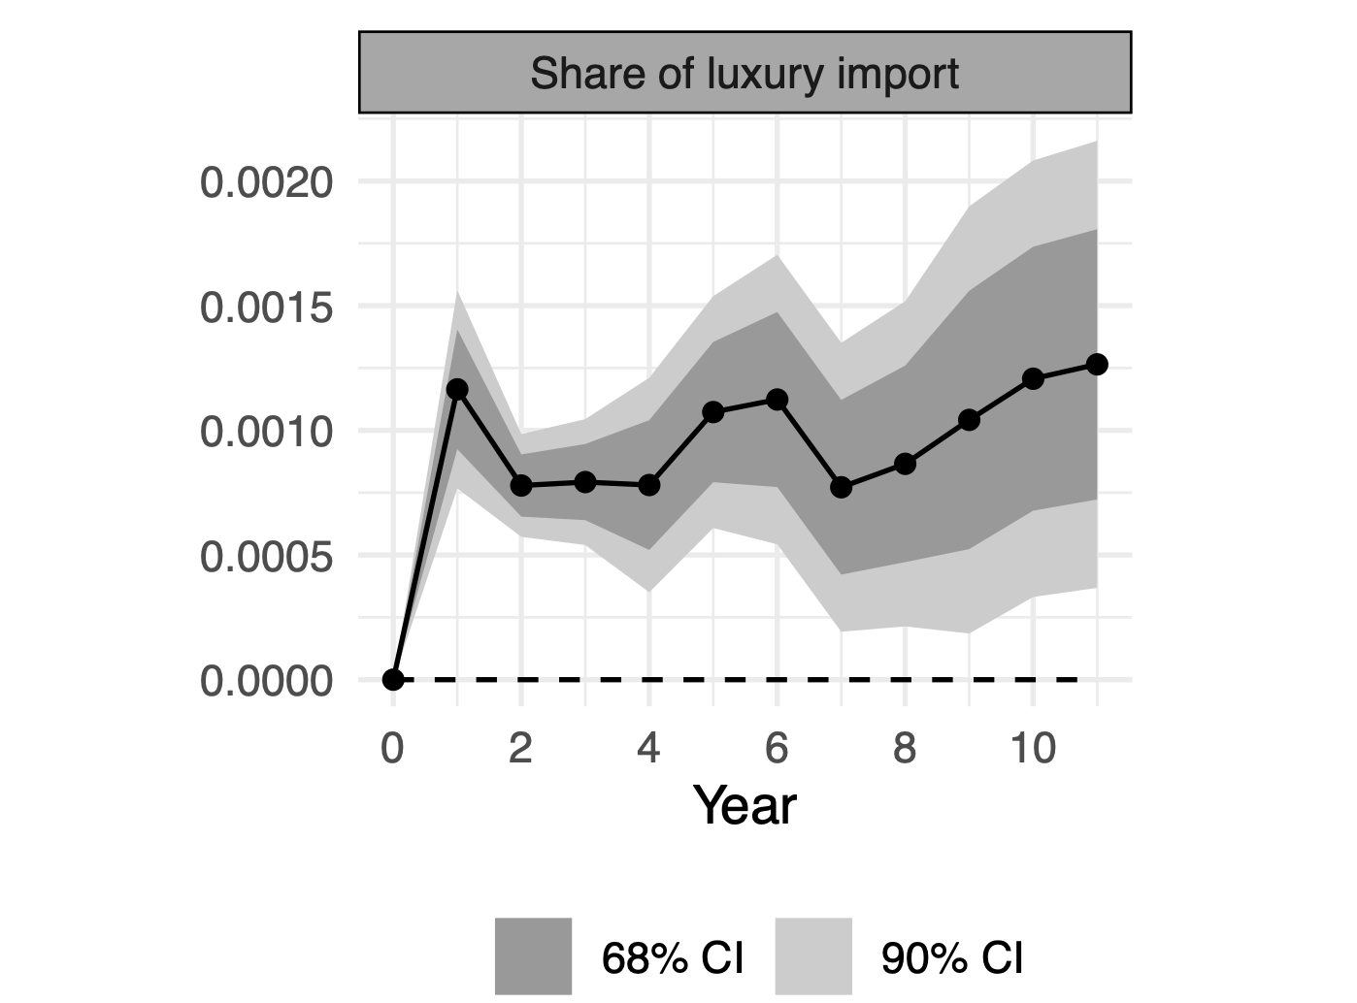

Note: This figure presents the impulse responses of the share of luxury goods in total good imports to a unit increase in the IMF’s Commodity Price Index, where individual commodities are weighted by their export-to-GDP ratio. All import values used in the computation of the ratio are in current US dollars. The dots indicate point estimates. The dark and light grey areas denote 90% and 68% confidence intervals, respectively. Data are for 192 countries and 9 categories of goods between 1992-2023.
We also explore the heterogeneity of the responses of luxury imports to commodity price shocks. The strongest positive response of luxury imports is in the categories of Precious Stones and Jewellery; Watches; Leather, Fur and Skins; and Furnitures. This suggests that the categories of luxury goods that have dual motives (both conspicuous and as an investment/store of value) respond more to commodity windfalls than luxury products which are just conspicuous in nature. The two motives are, however, intrinsically linked. These results confirm that commodity windfalls drive the (relative) demand for luxury goods, but the effects are heterogeneous across categories of luxury goods.

Heterogeneity across institutions and levels of income quality
Beyond heterogeneity in the response of different categories of luxury goods, there could also be important dimensions of heterogeneity in the response of luxury imports across institutional characteristics linked to the economies subjected to commodity windfalls. We therefore explore whether differences in income and institutions across countries lead to heterogeneity in the response of luxury imports to commodity windfalls. Indeed, a skewed income distribution should lead to bigger response of luxury consumption at the aggregate level compared to a situation where incomes are more equally distributed.
Our results show the responses of shares of luxury imports classifying countries as bottom and top levels of inequality measured using the Gini coefficient. Across the board, a more pronounced level of inequality leads to bigger aggregate responses of luxury consumption following commodity windfalls. Furthermore, results also show the role of institutional characteristics in shaping the response of luxury imports. Interestingly, we find stronger effects in less democratic countries (as measured by the V-Dem Democracy Index) and countries with less corruption controls (as measured by the World Governance Indicator).

Conclusion and policy implications
Our findings highlight the relevance of the (conspicuous consumption) channel of the resource curse stemming from the link between easy money and easy spending in a context of weak and often hidden mechanisms for resource allocation. One prominent explanation of the resource curse is the Dutch disease, where a resource windfall leads to an appreciation of the real exchange and a decline of the traded sector.
We have highlighted a novel channel of the resource curse that focuses on the effect of the wealth bonanza on the imports of luxuries. If anything, this channel will attenuate standard Dutch disease effects. Instead, our channel stems from the ‘rules’ of allocation of resource revenues leading to a relatively small group engaging in conspicuous consumption at the expense of current and future generations.
From a normative perspective, it could be argued that the wealth effect from a commodity price terms-of-trade shock is an equilibrium phenomenon and is not sub-optimal per se. That said, the disproportionate bias towards spending on consumption – here, conspicuous in nature rather than investment – is the result of a friction in the way the windfall is allocated between individuals (elite versus non-elite groups), leading to a suboptimal response to the aggregate wealth effect compared to the case without friction. This calls for institutional reforms to ensure a fairer distribution of commodity windfalls. Another policy option to help limit this apparent market failure of socially wasteful conspicuous consumption is to implement a Pigouvian tax to reduce conspicuous consumption.

References
Arezki, R, H Nguyen F van der Ploeg (2025), “Easy Money, Easy Spending: Evidence from Commodity Export Windfalls”, CESifo Working Paper No. 12088.
Arezki, R, A Fernandes, F Merchan, H Nguyen, and T Reed (2025), “Natural Resource Dependence and Monopolized Imports”, The Review of Economics and Statistics 7: 1–36.
Arezki, R, V A Ramey, and L Sheng (2017), “News Shocks in Open Economies: Evidence from Giant Oil Discoveries,” The Quarterly Journal of Economics 132(1): 103–155.
Bourdieu, P (1979), La distinction: Critique sociale du jugement, Editions de Minuit.
Collier, P, F Van Der Ploeg, M Spence, and A J Venables (2010), “Managing Resource Revenues in Developing Economies,” IMF Staff Papers 57(1): 84–118.
van der Ploeg, F and A J Venables (2011), “Harnessing Windfall Revenues: Optimal Policies for Resource-Rich Developing Economies,” The Economic Journal 121(551): 1–30.
van Wijnbergen, S (1984), “The ‘Dutch Disease’: A Disease After All?”, The Economic Journal 94(373): 41.
Veblen, T (1899), The Theory of the Leisure Class: An Economic Study of Institutions, Macmillan.

